Lab4

Important: Cloud resources might not be free, so please delete all resources after using them.

Part 1: Google Cloud Platform (GCP)
(4 marks)

- Go to GCP (console.cloud.google.com) and create a project, enable the API if asked to do so.
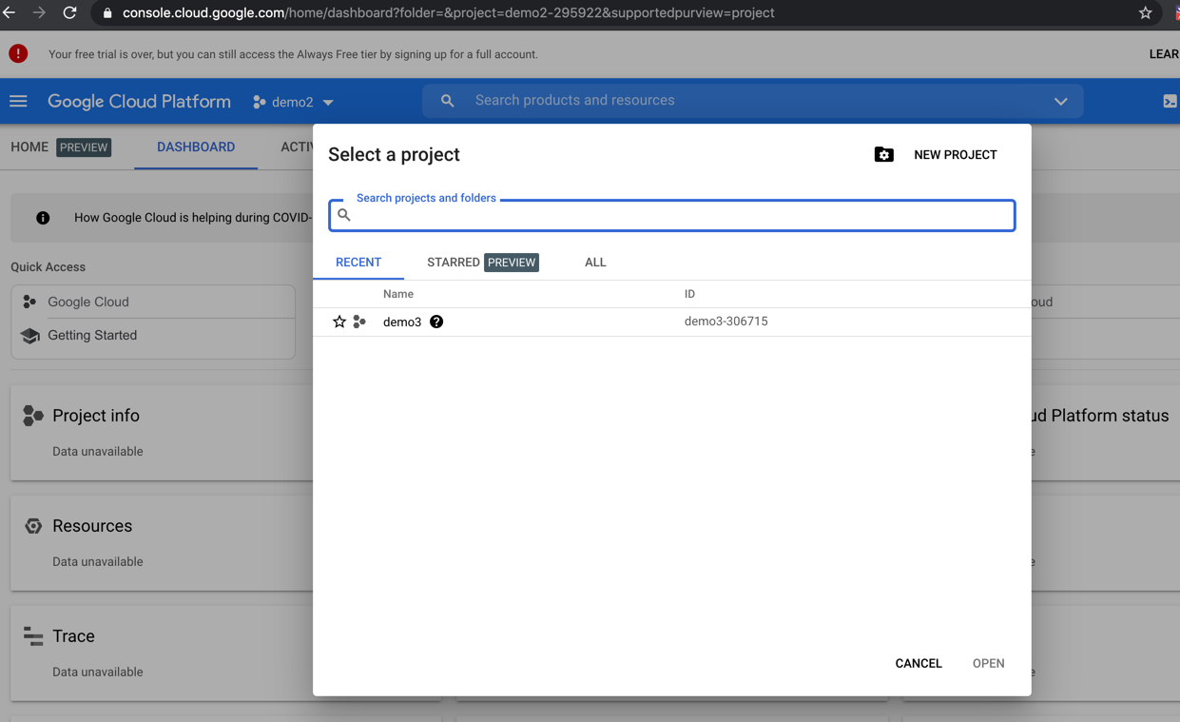

- Go to Kubernetes Engine and create a standard cluster, keep the defaults (creating a cluster might take few minutes)
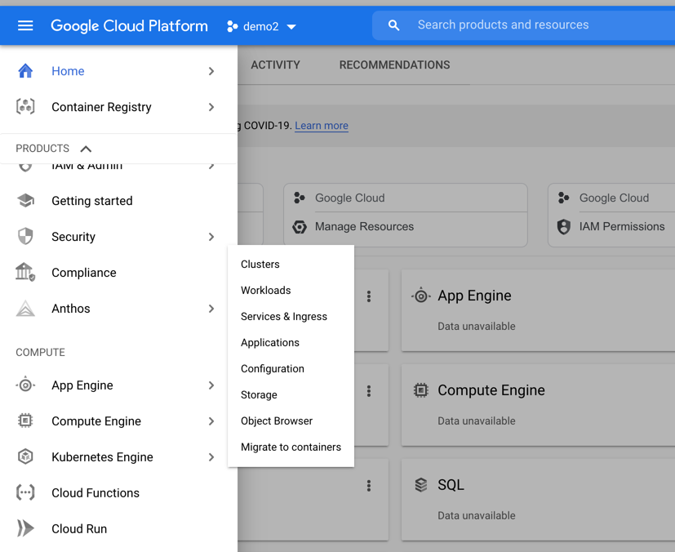

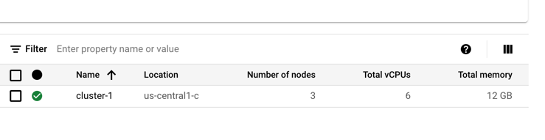

- Click on the cluster name, then click on Connect, then click on “Run in Cloud Shell” to open the cloud shell, then click “Authorize”. The cloud shell will appear at the bottom of the screen.

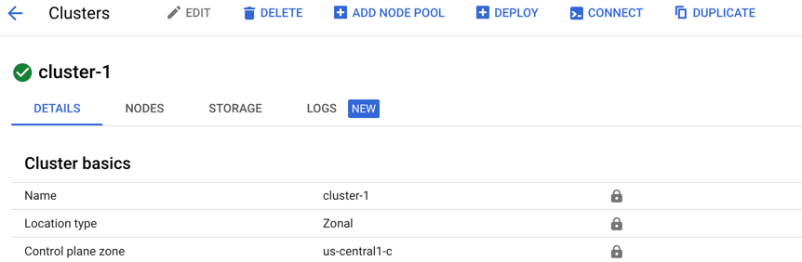

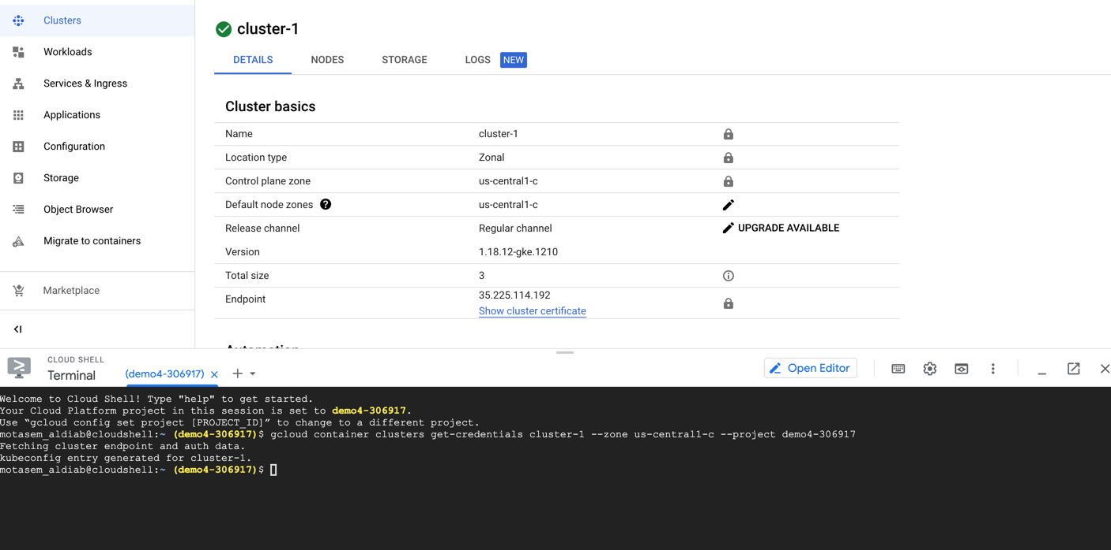

- Now you are connected to the cluster, you can run kubectl commands from the shell:
kubectl get nodes
kubectl get pods
…etc

- Create a deployment (use any of the images you have to run a website), expose it using the shell. Check that the website is up and running (live with real IP address).
- Step 5 can be done using the GUI as well. Click on the Deploy button (in the above image) and proceed with another deployment for another website. Check that whatever K8S resources created from the GUI is matching the shell.

Commands you can benefit from:

kubectl create deployment app1 --image=aldiab/webapp:v1

kubectl get nodes

kubectl expose deployment app1 --type LoadBalancer --port 80 --target-port 8080

kubectl get deployments

kubectl get replicasets

kubectl scale deplyment app1 --replicas 3

kubectl get pods

kubectl get services

Part2: Amazon Web Services (AWS)
(4 marks)

- Install AWS CLI on your machine

- Go to https://docs.aws.amazon.com/cli/latest/userguide/cli-chap-install.html
- Alternatively, you can just google it and know how to install aws cli on your machine. Google type “aws cli install”
- Check that using aws -- version command

- Create a user under your AWS account and configure aws cli

- Go to IAM then Users, Add a user with programmatic access

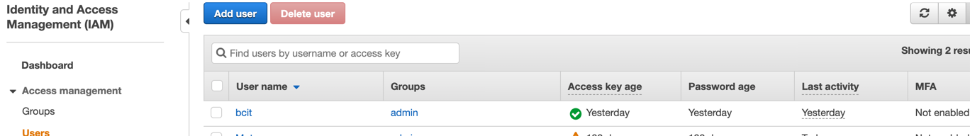

- Get the security credentials for your user (download the csv file to your local machine)
- Use command aws configure on your local machine (Enter your credentials and the region name)

- Install eksctl on your machine. Look at this link for more info on EKSCTL https://docs.aws.amazon.com/eks/latest/userguide/getting-started-eksctl.html
- Try commands eksctl version , ecksctl, eckctl create --help
- Create a cluster using command (that might take 15 minuets)
eksctl create cluster –name=week9lab –region=ca-central-1 --node-type=t3.small –managed (it might take up to 15 mins)
- On your AWS account check CloudFormation and EKS clusters – you can check EC2 as well and VPC.
- Once you have your cluster created, that’s it Kubernetes is Kubernetes …. Do the previous steps you did in the previous labs to deploy an image and open the website using the load balancer external IP address.
- After you finish, delete the cluster using eksctl delete cluster --region=ca-central-1 –name=week9lab
- Check from your AWS account that everything is deleted.

Part3 (2 marks): Microsoft Azure
Can you deploy a web app on Azure Kubernetes Cluster? Look at the following YouTube videos and do something similar to Part1 using Azure instead of GCP.

https://www.youtube.com/watch?v=Zdcrv23WhWE

https://www.youtube.com/watch?v=nTdvRNOmur4

Again: Don’t forget to delete all AWS/GCP/Azure resources you used after finishing

